Amazon Sales

1.Context
This dataset contains transactional Amazon sales data, including order details, product information, shipping attributes, and financial metrics.
The goal of this project is to develop a machine learning model to predict sales revenue and analyze customer and order behavior to extract actionable insights.

2. Project Objectives
- Build a regression model to predict sales amount (Amount)
- Perform exploratory data analysis (EDA) to understand sales patterns
- Analyze order behavior (e.g., shipped, cancelled, returned)
- Detect and handle unrealistic or anomalous data (e.g., zero or extreme values)
- Identify key features influencing sales performance

3. Attribute information

3.1Order Information
- Order ID: Unique identifier for each order
- Date: Order date
- Status: Order status (Shipped, Cancelled, etc.)

3.2Product Information
- Category: Product category (e.g., kurta, dress)
- SKU: Stock Keeping Unit
- Style: Product style/type
- Size: Product size

3.3Logistics & Shipping
- Fulfilment: Fulfillment method (Amazon / Merchant)
- ship-service-level: Shipping speed (Standard / Expedited)
- ship-city: Delivery city
- ship-state: Delivery state
- ship-country: Delivery country

3.4Financial Information
- currency: Currency type
- Amount: Total sales amount (target variable)

3.5Business Features
- B2B: Business-to-business indicator
- promotion-ids: Applied promotions
- fulfilled-by: Fulfillment service type

4 Overview of data
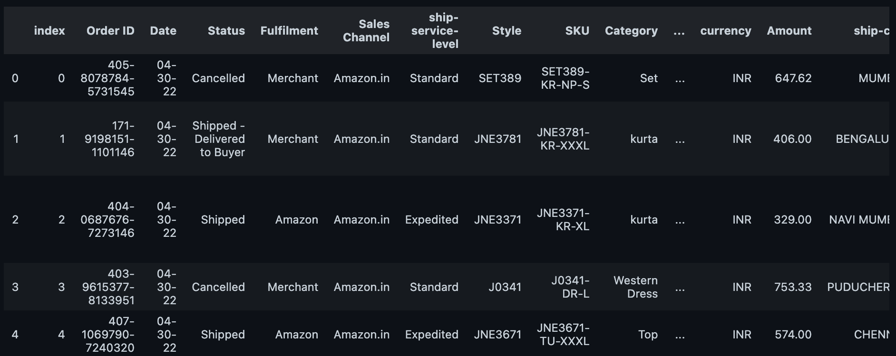
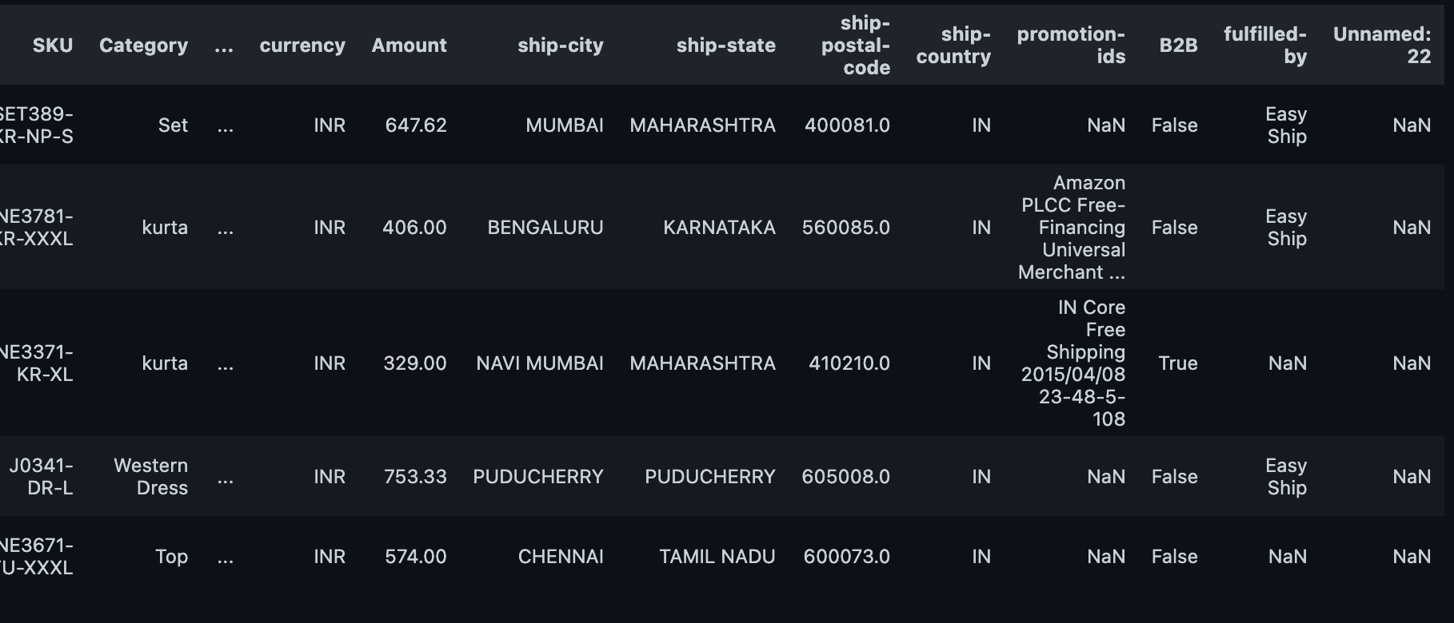

5. Data Information
